## System Overview

The Weekly Accomplishment System is a web-based tool for OJT students to track their daily work activities and schedules.

---

## Getting Started

### First-Time Login

Step 1 Open your web browser.

Step 2 Type the system website address in the address bar. (192.168.0.219/projects)

Step 3 Press Enter to go to the login page.

Step 4 Type your username in the username field.

Step 5 Type your password in the password field.

Step 6 Click the "Login" button.

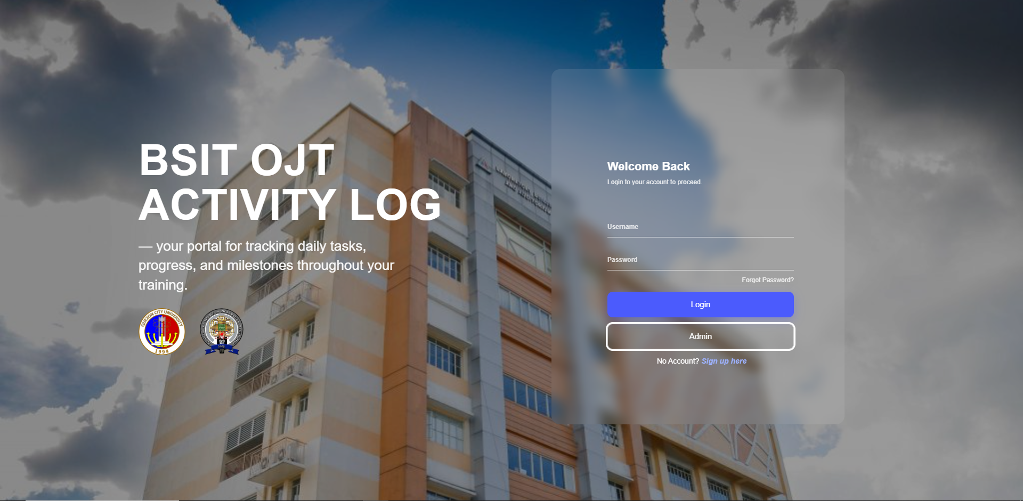

Step 7 The system will open to the main dashboard.

### Creating a New Account

Step 1 Go to the login page by following steps 1-3 above.

Step 2 Look for the "Sign up Here” link on the login page.

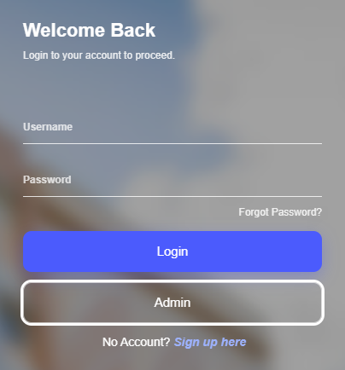

Step 3 Click the "Sign up Here" link.

Step 4 Fill in your desired username in the username field.

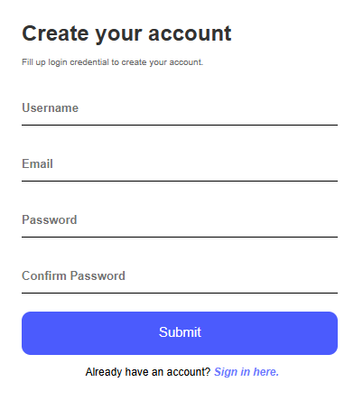

Step 5 Type your email address in the email field.

Step 6 Create a strong password and type it in the password field.

Step 7 Confirm your password by typing it again in the "Confirm Password" field.

Step 8 Click the "Submit" button.

Step 9 Wait for the notification pops out that indicate that you create your account.

### Forgot Password Recovery

Step 1 Go to the login page.

Step 2 Look for the "Forgot Password?" link below the login form.

Step 3 Click the "Forgot Password?" link.

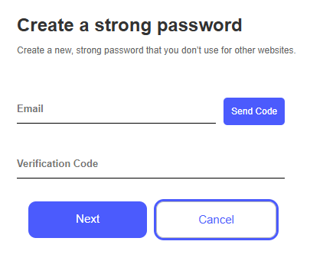

Step 4 Type your email address in the email field.

Step 5 Click the "Send Reset Code" button.

Step 6 Check your email for a verification code message it last until 3 minutes.

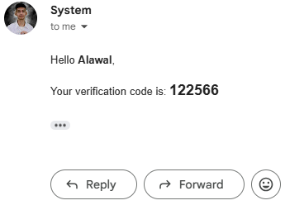

Step 8 Copy the reset code from the email.

Step 9 Return to the system website.

Step 10: Enter the reset code in the verification field.

Step 11 Type your new password in the "New Password" field.

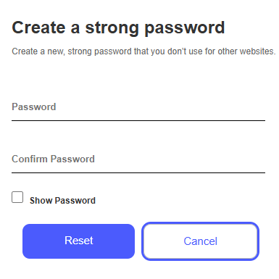

Step 12 Confirm your new password by typing it again.

Step 13 Click the "Reset" button.

Step 14 Your password will be updated.

Step 15 Use your new password to log in to the system.

###Locked Accounts ( If account was locked by the 3 attempts of inputting wrong passwords )  
  
Step 1 Go to “forgot password” in Login page  
Step 2 Input the Email used in that account gets locked  
Step 3 Click the “Send” to send the verification code

Step 4 Open the email then copy the verification code  
Step 5 Input it in the “Verification code” field ( the code will be expired after 3 minutes )

Step 6 Click next if the code was valid   
Step 7 Input the “new password”  
Step 8 Input the “Confirm password”  
Step 9 After clicking the “Submit” button you can now sign in that account

### Initial Profile Setup (First Time Only)

Step 1 Click on your profile picture or name in the top right corner.

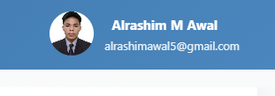

Step 2 Click "Edit Profile" to open the profile form.

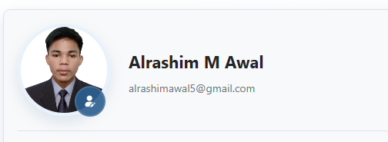

Step 3 Fill in your first name in the "First Name" field.

Step 4 Fill in your last name in the "Last Name" field.

Step 5 Type your email address in the "Email" field.

Step 6 Enter your course name in the "Course" field.

Step 7 Select your year level from the dropdown menu.

Step 8 Click "Save Changes" to save your information.

Step 9 Click "Cancel" if you want to exit without saving.

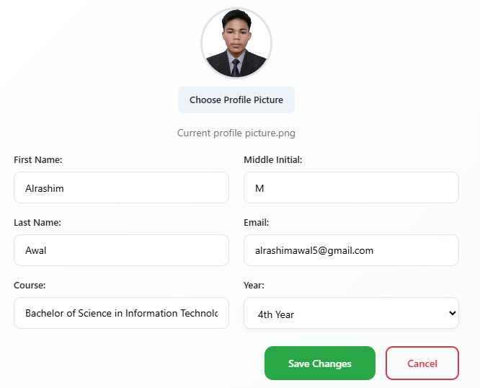

## Dashboard Navigation

### Understanding the Main Screen

Step 1 After logging in, you will see the main dashboard.

Step 2 Look at the left side to find the navigation menu with 4 options.

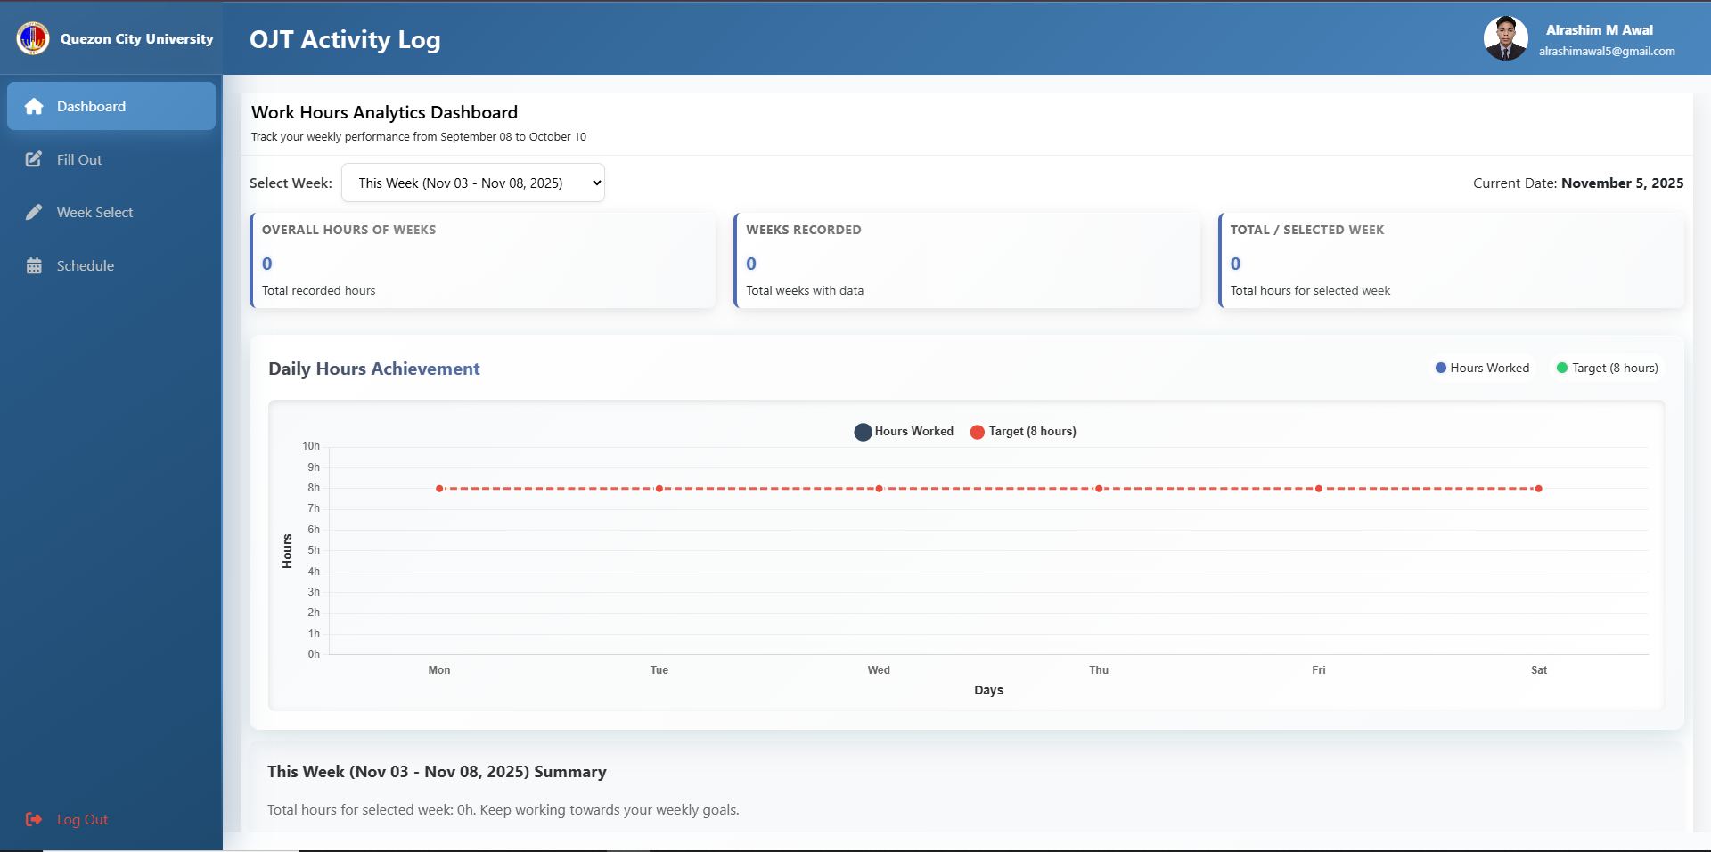

Step 3 Notice the "Dashboard" button (house icon) which brings you to the main page.

Step 4 Find the "Fill Out" button (pencil icon) for recording daily activities.

Step 5 Locate the "Week Select" button (pen icon) for changing weeks.

Step 6 See the "Schedule" button (calendar icon) for setting work hours.

### Using the Navigation Menu

Step 1 Click any menu item on the left to switch to that section.

Step 2 The active section will be highlighted in a different color.

Step 3 Click "Dashboard" anytime to return to the main view.

### Understanding the Header Area

Step 1 Look at the top right corner to see your profile information.

Step 2 Your profile picture appears as a small circle.

Step 3 Your name is displayed next to the picture.

Step 4 Your email address appears below your name.

Step 5: Click on your name or picture to access profile settings.

---

## Profile Management

### Opening Your Profile

Step 1 Click on your profile picture in the top right corner.

Step 2 A modal window will open showing your profile information.

Step 3 Review the information currently displayed.

### Editing Basic Information

Step 1 Click the "Edit Profile" button or icon.

Step 2 The form fields will become editable.

Step 3 Click in the "First Name" field to change your first name.

Step 4 Click in the "Last Name" field to change your last name.

Step 5 Click in the "Email" field to update your email address.

Step 6 Click in the "Course" field to change your course name.

Step 7 Click the "Year Level" dropdown to select 1st, 2nd, 3rd, or 4th year.

### Adding Profile Picture

Step 1 Look for the "Profile Picture" section in the edit form.

Step 2 Click the "Choose File" or "Browse" button.

Step 3 Navigate to the folder containing your picture on your computer.

Step 4 Select a JPG, PNG, or GIF image file.

Step 5 Make sure the file is smaller than 5MB.

Step 6 Click "Open" to select the image.

### Saving Profile Changes

Step 1 After making all your changes, scroll to the bottom of the form.

Step 2 Click the "Save Changes" button to save your updates.

Step 3 Wait for the confirmation message that changes were saved.

Step 4 Click "Cancel" if you decide not to save changes.

Step 5 The profile modal will close automatically after saving.

---

## Recording Daily Activities

### Opening the Fill Out Form

Step 1 Click "Fill Out" in the left navigation menu.

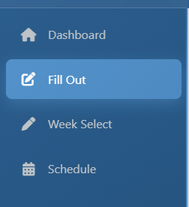

Step 2 The daily activity form will appear on the screen.

Step 3 Make sure you're viewing the current week (check the date range displayed).

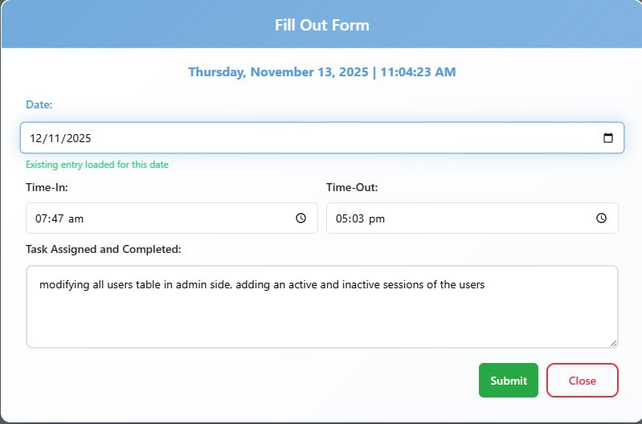

### Entering Your Time In

Step 1 Click in the "Time In" field.

Step 2 Select on th dropdown menu of the desired Time-in, Time-out.

Step 3 Then input the assign task or completed task.

Step 4 Click the “Submit” button

---

## Schedule Management

### Opening Schedule Settings

Step 1 Click "Schedule" in the left navigation menu.

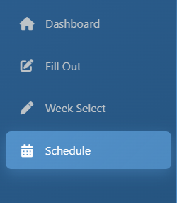

Step 2 A modal window will open showing the weekly schedule form.

Step 3 You will see input fields for Monday through Saturday.

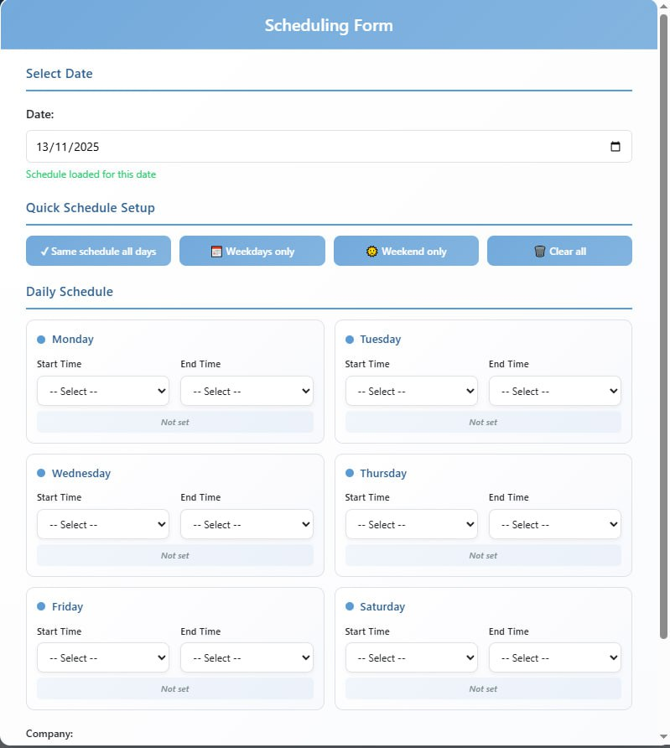

### Setting Individual Day Schedules

Step 1 Click in the "Monday" time field.

Step 2 Type your Monday working hours (example: "8:00 AM - 5:00 PM").

Step 3 Click in the "Tuesday" time field and enter Tuesday hours.

Step 4 Continue for Wednesday, Thursday, Friday, and Saturday.

Step 5 Leave a day blank if you don't work that day.

### Using Quick Schedule Options

Step 1 Look for the quick action buttons before the time fields.

Step 2 Click "Same schedule all days" to apply one schedule to all days.

Step 3 First, fill in Monday's hours, then click this button.

Step 4 Click "Weekdays only" to set schedule for Monday through Friday only.

Step 5 Click "Weekend only" to set schedule for Saturday only.

### Adding Company Information

Step 1 Find the "Company" field in the schedule form.

Step 2 Type the name of the company where you're doing OJT.

Step 3 Make sure the spelling is correct.

### Saving Your Schedule

Step 1 Review all the times you entered to make sure they're correct.

Step 2 Check that your company name is spelled correctly.

Step 3 Click the "Submit" button to save your schedule.

Step 4 Wait for the confirmation that your schedule was saved.

Step 5 Click "Close" to exit without saving if you change your mind.

---

## Week Navigation

### Understanding Week Selection

Step 1 Click "Week Select" in the left navigation menu.

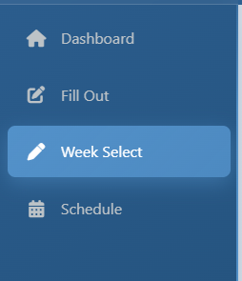

Step 2 You will see dropdown menus for selecting week and year.

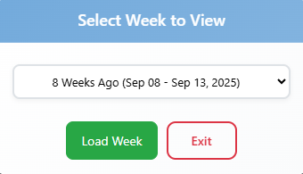

Step 3 The current week is shown by default when you first login.

### Viewing Different Weeks

Step 1 Click the "Week" dropdown menu.

Step 2 Select a week number from what week did you start

Step 4 Select the week you want to view.

Step 5 The page will automatically load data for the selected week.

### Understanding Week Data

Step 1 After selecting a week, look at the main content area.

Step 2 You will see any activities you recorded for that week.

Step 3 Past weeks show your historical data (usually cannot be edited).

Step 4 Current week data can be edited and updated.

Step 5 Future weeks are usually empty until you reach those dates.

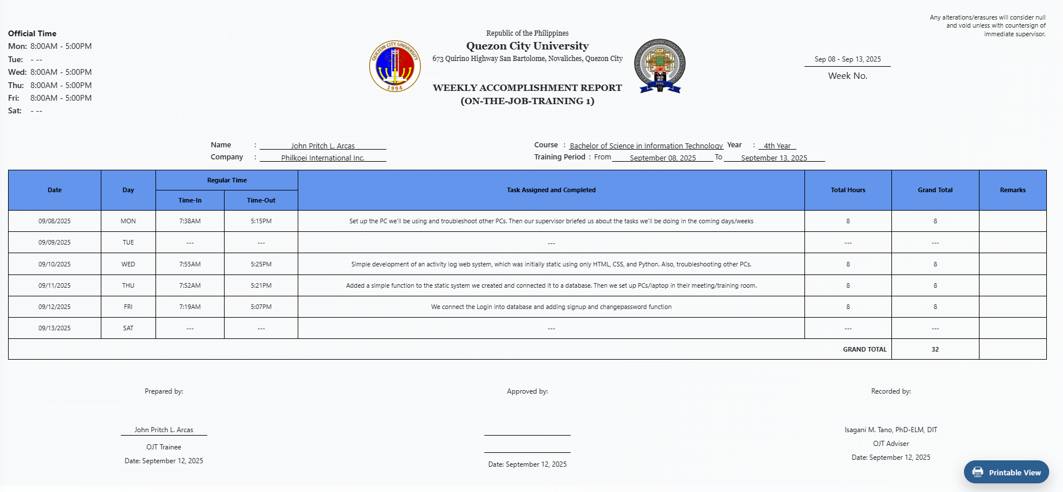

### Returning to Current Week

Step 1 To go back to the current week, click "Week Select" again.

Step 2 Select the current week number from the dropdown.

Step 3 Select the “This Week”.

Step 4 The current week will load with editable forms.

## Printing Reports

### Opening Printable View

Step 1 Look for the floating "Printable View" button (it shows a printer icon).

Step 2 The button is usually located at the bottom right of the screen.

Step 3 Click the "Printable View" button.

Step 4 A new window or tab will open with your formatted report.

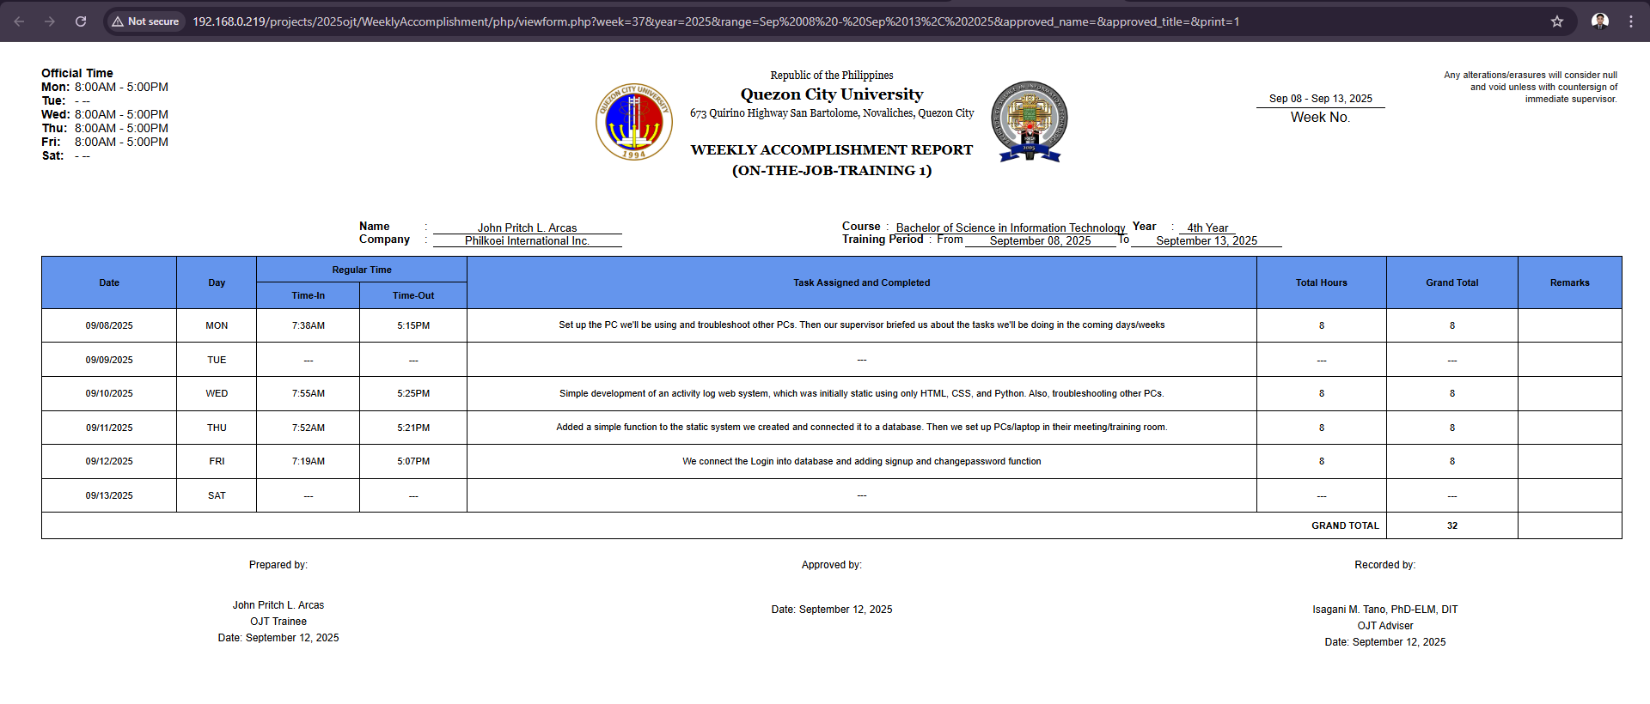

### Understanding the Report Layout

Step 1 The report shows your name and profile information at the top.

Step 2 Your company name and course details are displayed.

Step 3 A table shows your weekly schedule with official working hours.

Step 4 Daily activity entries are listed with dates, times, tasks, and total hours.

### Printing the Report

Step 1 Make sure the printable view window is active (click on it if needed).

Step 2 Press Ctrl+P on Windows or Cmd+P on Mac to open print dialog.

Step 3 Click "Print" to print the report.

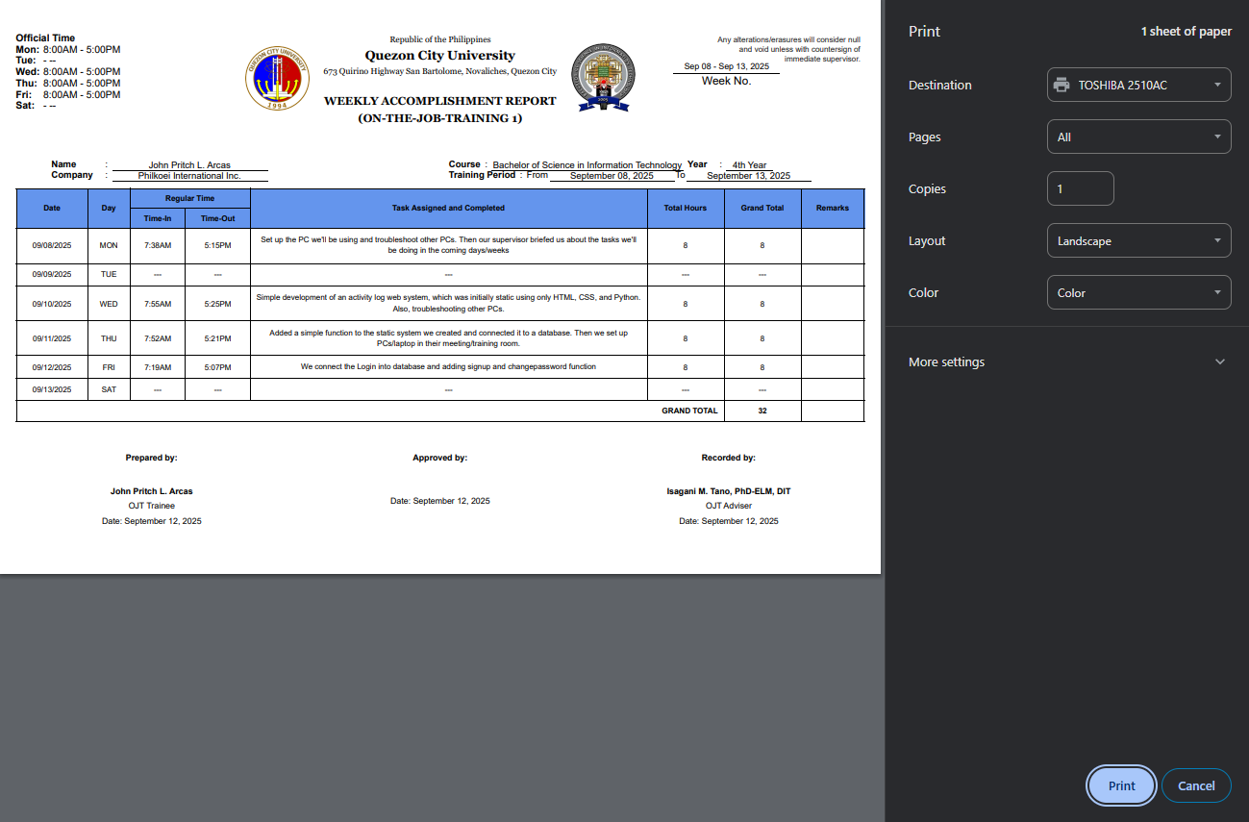

---

This step-by-step manual helps OJT students effectively use the Weekly Accomplishment System. Follow each step in order for best results.